MAWW LinkedIn Profiles: Former Board Member + Partner (via Member Name)

Former Board Member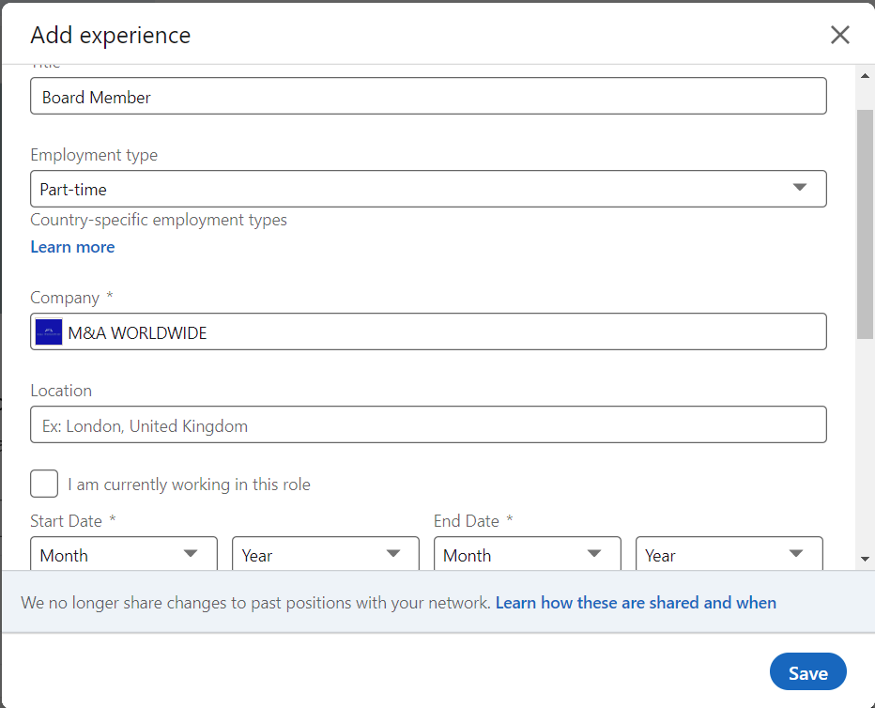 | Company Name: M&A WORLDWIDE  Board Member  Dates Employed from the entrance date as Board Member – Until the end date as Board Member.
Partner (via Member Name) 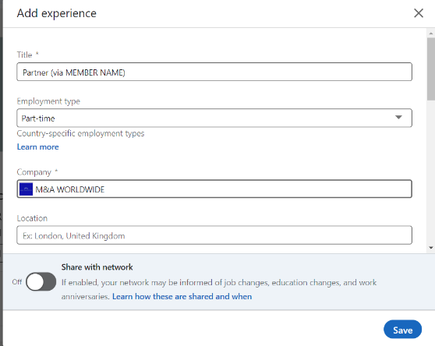 | Should add a new collaboration with MAWW, but now as a Partner (via Member name) From the Date that you exited the Board until Present  Title Partner (via Member Name)  Dates Employed from the Date that you exited – Present
Text to insert in the Description field:  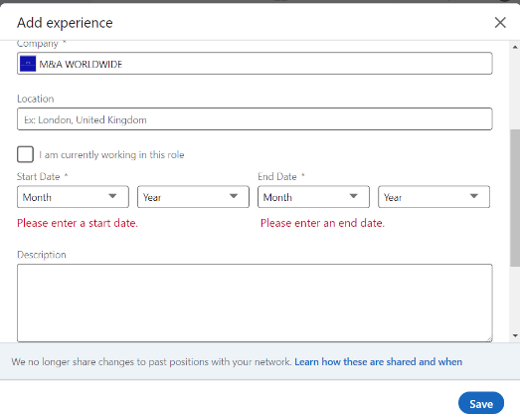 | Established in 2004, M&A WORLDWIDE is a global corporate finance advisory organization specifically focused on cross-border advice to the mid-market (deal values of €5m - €200m). We provide dedicated corporate financial advisory services (M&A advice) to mid-market clients looking for global transactions. In 2020, reporting offices of M&A WORLDWIDE completed 553 deals with a value of €3,29 Billion which places M&A WORLDWIDE in the top best-performing M&A advisors with regards to completed number of deals.

